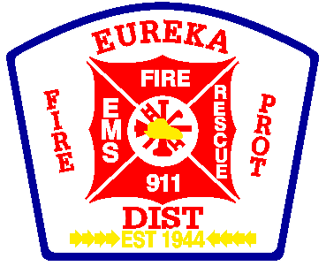Eureka Fire Protection District

**E**mergency **F**ire • **M**edical • **R**escue • **F**ire **P**revention **S**ervices

**YOU ARE INVITED TO SUBMIT SEALED BIDS ON THE FOLLOWING**:

Swiftwater Gear For Personnel

For more information, please contact Scott Barthelmass ([sbarthelmass@efpd.org](mailto:sbarthelmass@efpd.org)) or at 636-938-5505.

All bids shall include information on the design and construction of the products and warranty information.

All purchases shall be done tax exempt

The Board of Directors reserves the right to reject all bids and also the right to take any bid whether or not it was lowest if in the judgment of the Board of Directors the quality of the items submitted on bids justify taking other than the lowest one. The Board of Directors reserves the right to reject any or all bids and to waive any technicalities as may be contained in the bids and also reserves the right to reject items on delivery, if at that time it does not meet the satisfaction of the Board of Directors.

SEALED BIDS MUST BE RECEIVED AT THE ADMINISTRATIVE OFFICES OF THE EUREKA FIRE PROTECTION DISTRICT, 4849 HIGHWAY 109, PO BOX 97 EUREKA, MISSOURI 63025 BY:

**November 22, 2024, 4:30 pm**

**The bid will be awarded**

**November 26, 2024 after 5:30pm**

**During the regularly scheduled**

**Eureka Fire Protection District Board Meeting**

The Eureka Fire Protection District **Bid Proposal Form** must be completed and placed at the front of all bids submitted.

**Eureka Fire Protection District**

**PO Box 97**

###### 4849 Hwy 109

**Eureka, MO 63025**

**(636) 938-5505**

#### Bid Proposal Form

________________________________________________________ (bidder),

Hereby proposes to furnish to the Eureka Fire Protection District Swiftwater Gear, including: Dry suits, boots with zipper, life jackets, gloves, googles, lights, whistles, knives, throw bags, zipper wax (for each suit) and gear storage bag. 18 total complete sets.

Total Price: $________________________

Bid price good for __________________________ days

Signed: ___________________________

Title: ___________________________

Company: ___________________________

Address: ____________________________

Date: ___________________________

**Eureka Fire Protection District**

**PO Box 97**

###### 4849 Hwy 109

**Eureka, MO 63025**

**(636) 938-5505**

18 swiftwater drysuits (sizes to be determined)

18 swiftwater life jackets

18 sets of boots with zipper

18 sets of gloves

18 googles

18 lights

18 whistles

18 knives

18 throw bags

18 things of zipper wax (for each suit)

18 Gear storage bags (1 for each set of above gear)